**Logging using SLF4J**

**Exercise 1: Logging Error Messages and Warning Levels**

**Task:** Write a Java application that demonstrates logging error messages and warning levels using SLF4J.

**CODE**:

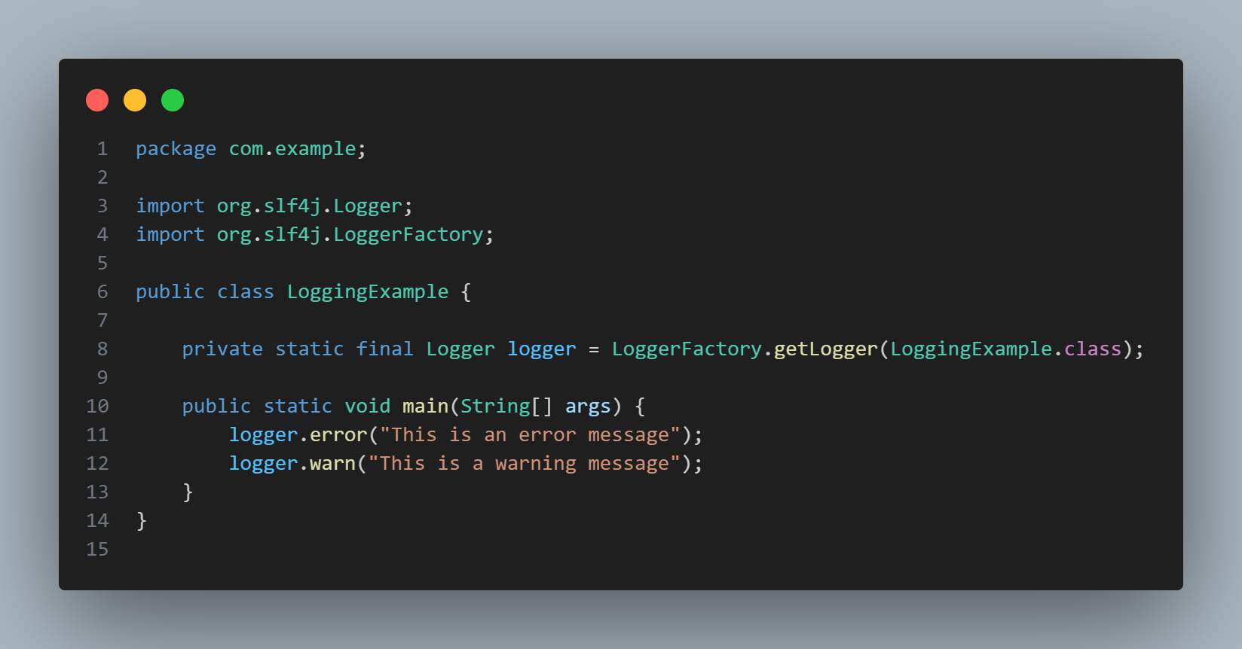

**OUTPUT:**

